Final Project Report Template

1. Introduction
   1. Project overviews
   2. Objectives
2. Project Initialization and Planning Phase
   1. Define Problem Statement
   2. Project Proposal (Proposed Solution)
   3. Initial Project Planning
3. Data Collection and Preprocessing Phase
   1. Data Collection Plan and Raw Data Sources Identified
   2. Data Quality Report
   3. Data Exploration and Preprocessing
4. Model Development Phase
   1. Feature Selection Report
   2. Model Selection Report
   3. Initial Model Training Code, Model Validation and Evaluation Report
5. Model Optimization and Tuning Phase
   1. Hyperparameter Tuning Documentation
   2. Performance Metrics Comparison Report
   3. Final Model Selection Justification
6. Results
   1. Output Screenshots
7. Advantages & Disadvantages
8. Conclusion
9. Future Scope
10. Appendix
    1. Source Code
    2. GitHub & Project Demo Link

**1.Introduction**

In today's world, almost everyone has a mobile phone, and text messaging has

become extremely popular. But along with this popularity comes a significant

issue: spam. Spam messages are those annoying and sometimes harmful texts

that flood our phones, attempting to sell us products or deceive us into revealing

personal information. To address this problem, we can employ technology like

machine learning, which has the ability to automatically identify and filter out

spam messages. One effective technique is the Multinomial Naive Bayes

classifier.

* 1. **Project Overview**

The SMS Spam Detection Project aims to create an automated system that effectively identifies and filters spam messages from legitimate ones, enhancing user security and experience. Leveraging machine learning algorithms, the project will analyze SMS content to classify messages accurately. It will encompass data collection, preprocessing, model training, and validation phases, ensuring the system adapts to evolving spam tactics. Key stakeholders include end-users, development teams, and mobile service providers, all invested in reducing spam's negative impact. A user-friendly interface will allow users to report inaccuracies, contributing to continuous improvement.

**1.2 Objectives of SMS Spam Detection**

--Identify Spam Messages: Accurately classify incoming SMS messages as spam or legitimate based on predefined criteria and patterns.

--Enhance User Experience: Reduce the volume of unwanted messages received by users, ensuring they can focus on important communications.

--Protect User Privacy: Safeguard users from potential privacy breaches and malicious content that often accompanies spam messages.

--Reduce Fraud Risk: Mitigate the risks associated with phishing and other scams that can be propagated through spam SMS**.**

**2.Project Initialization and Planning Phase**

**2.1 Define Problem Statements**

| Date | 15 August 2024 |
| --- | --- |
| Team ID | LTVIP2024TMID24955 |
| Project Name | SMS Spam Detection - Aiml |
| Maximum Marks | 3 Marks |

**Define Problem Statements**

As a mobile user, I frequently receive unsolicited and unwanted SMS messages that disrupt my daily activities. These spam messages often contain misleading information, fraudulent offers, or malicious links that put my privacy and security at risk. I need an efficient and reliable solution that can accurately detect and filter out spam messages before they reach my inbox

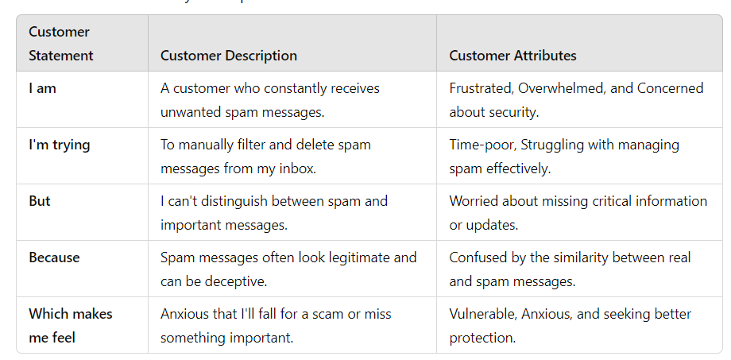

**Example:**

|  |  |  |  |  |  |
| --- | --- | --- | --- | --- | --- |
| **Problem**  **Statement (PS)** | **I am**  **(Customer)** | **I’m trying to** | **But** | **Because** | **Which makes me feel** |
| PS-1 | Receiving unwanted messages | Filtering | I can’t find ham or spam | Often looks likes Legitimate | Anxious, Scared of falling in scam |
| PS-2 | Receives Suspicious links in messages | Detecting | I don’t know  About it | Confused by Ham or Spam | Worried, Seeking peace of mind. |

**Project Initialization and Planning Phase**

**2.2 Project Proposal (Proposed Solution) template**

|  |  |
| --- | --- |
| Date | 15 March 2024 |
| Team ID | LTVIP2024TMID24955 |
| Project Title | SMS Spam Detection - AIML |
| Maximum Marks | 3 Marks |

**Project Proposal (Proposed Solution) template**

This project proposal outlines a solution to address a specific problem. With a clear objective, defined scope, and a concise problem statement, the proposed solution details the approach, key features, and resource requirements, including hardware, software, and personnel.

|  |  |
| --- | --- |
| **Project Overview** | |
| Objective | Clearly state the project's primary objective |
| Scope | Define the boundaries and extent of the project |
| **Problem Statement** | |
| Description | Clearly articulate the problem to be addressed |
| Impact | Explain the implications of solving the problem |
| **Proposed Solution** | |
| Approach | Outline the methodology and techniques to be used |
| Key Features | Highlight the unique aspects of the proposed solution |

**Resource Requirements**

|  |  |  |
| --- | --- | --- |
| **Resource Type** | **Description** | **Specification/Allocation** |
| **Hardware** | | |
| Computing Resources | CPU/GPU specifications, number of cores | e.g., 2 x NVIDIA V100 GPUs |
| Memory | RAM specifications | e.g., 8 GB |
| Storage | Disk space for data, models, and logs | e.g., 512 GB SSD |
| **Software** | | |
| Frameworks | Python frameworks | e.g., Flask |
| Libraries | Additional libraries | e.g., scikit-learn, pandas, numpy , matplotlib |
| Development Environment | IDE, version control | e.g., Jupyter Notebook, Git |
| **Data** | | |
| Data | Source, size, format | e.g., Kaggle dataset, 5374 KB Size, CSV format |

**2.3 Initial Project Planning Template**

|  |  |
| --- | --- |
| Date | 15 August 2024 |
| Team ID | LTVIP2024TMID24955 |
| Project Name | SMS Spam Detection - AIML |
| Maximum Marks | 4 Marks |

**Product Backlog, Sprint Schedule, and Estimation (4 Marks)**

Use the below template to create a product backlog and sprint schedule

| **Sprint** | **Functional Requirement (Epic)** | **User Story Number** | **User Story / Task** | **Story Points** | **Priority** | **Team Members** | **Sprint Start Date** | **Sprint End Date (Planned)** |
| --- | --- | --- | --- | --- | --- | --- | --- | --- |
| Sprint-1 | SMS Spam Detection | USN-1 | As a user, I want to report spam messages so I can keep my inbox clean. | 2 | High | Chethala Katam Raju | 15-08-2024 | 22-08-2024 |
| Sprint-1 | SMS Spam Detection | USN-2 | As a user, I want the system to automatically filter spam messages to reduce clutter. | 1 | High | D Tandan Sai Nanda Krishna | 23-08-2024 | 30-08-2024 |
| Sprint-2 | SMS Spam Detection | USN-3 | As a user, I want to customize spam filters based on my preferences. | 2 | Low | Ganneboia Prabhas | 31-08-2024 | 08-09-2024 |
| Sprint-1 | SMS Spam Detection | USN-4 | As a user, I want to receive notifications when a spam message is detected. | 2 | Medium | Chadalavada Jaya Sai Kiran | 09-09-2024 | 16-09-2024 |
| Sprint-1 | SMS Spam Detection | USN-5 | As a user, I want an easy way to view my spam message history. | 1 | High | Chethala Katam Raju | 17-09-2024 | 28-09-2024 |

3**.Data Collection and Preprocessing Phase**

**3.1 Data Collection Plan & Raw Data Sources Identification**

|  |  |
| --- | --- |
| Date | 15 March 2024 |
| Team ID | LTVIP2024TMID24955 |
| Project Title | SMS Spam Detection - AIML |
| Maximum Marks | 2 Marks |

**Data Collection Plan & Raw Data Sources Identification Template**

Elevate your data strategy with the Data Collection plan and the Raw Data Sources report, ensuring meticulous data curation and integrity for informed decision-making in every analysis and decision-making endeavor.

**Data Collection Plan Template**

|  |  |
| --- | --- |
| **Section** | **Description** |
| Project Overview | The project focuses on building an SMS spam detection model that accurately classifies incoming SMS messages as spam or not spam. This involves collecting a diverse set of SMS data, including both spam and non-spam messages, to train, validate, and test machine learning models. |
| Data Collection Plan | Identify sources of SMS data such as public datasets, user-contributed data, or SMS archives from mobile service providers. Data can be collected from Kaggle datasets |
| Raw Data Sources Identified | The dataset will consist of SMS message content (text data), along with metadata like message timestamp, sender information, and spam/not spam labels |

**Raw Data Sources Template**

|  |  |  |  |  |  |
| --- | --- | --- | --- | --- | --- |
| **Source Name** | **Description** | **Location/URL** | **Format** | **Size** | **Access Permissions** |
| Dataset 1 | The data consists of meta data | https://drive.google.com/file/d/1Mf6AHsRuRxO8IynQFJGYi2OWwO4uWVh-/view?usp=sharing | CSV | 5374 KB | Public |

**Data Collection and Preprocessing Phase**

**3.2 Data Quality Report Template**

|  |  |
| --- | --- |
| Date | 15 March 2024 |
| Team ID | LTVIP2024TMID24955 |
| Project Title | SMS Spam Detection - AIML |
| Maximum Marks | 2 Marks |

**Data Quality Report Template**

The Data Quality Report Template will summarize data quality issues from the selected source, including severity levels and resolution plans. It will aid in systematically identifying and rectifying data discrepancies.

|  |  |  |  |
| --- | --- | --- | --- |
| **Data Source** | **Data Quality Issue** | **Severity** | **Resolution Plan** |
| Dataset | Mention the issues faced in the selected dataset. | Low/ Moderate/ High | Give the solution for that issue technically. |
| Dataset | Duplicate Records | Moderate | Implement deduplication processes to identify and remove duplicate entries from the dataset to ensure unique records. |
| Dataset | Inconsistent Formatting | High | Standardize formats for text fields (e.g., phone numbers, dates) to ensure uniformity across the dataset. |
| Dataset | Irrelevant Data | Low | Review the dataset to identify and remove unnecessary columns or records that do not contribute to the analysis. |
| Dataset | Missing Values | High | Identify and fill in missing values using imputation methods (mean, median, mode) or remove affected records if the missing percentage is significant. |

**Data Collection and Preprocessing Phase**

**3.3 Data Exploration and Preprocessing Template**

|  |  |
| --- | --- |
| Date | 15 August 2024 |
| Team ID | LTVIP2024TMID24955 |
| Project Title | SMS Spam Detection - AIML |
| Maximum Marks | 6 Marks |

**Data Exploration and Preprocessing Template**

Identifies data sources, assesses quality issues like missing values and duplicates, and implements resolution plans to ensure accurate and reliable analysis.

|  |  |
| --- | --- |
| **Section** | **Description** |
| 1. Data Collection | Gathering SMS message data from reliable sources such as SMS datasets (e.g., public datasets, user-contributed data, or synthetic data). Includes both spam and non-spam messages for balanced classification.. |
| 2. Data Inspection | Examining the structure of the dataset, including attributes such as message content, labels (spam/not spam), and metadata e.g., time of message, sender info. |
| 3.Exploratory Data Analysis (EDA) | Visualizing and analyzing the distribution of messages, word frequencies, and the relationship between message features (e.g., message length, most common words) and their labels (spam/not spam). |
| 4. Data Cleaning | Removing or correcting noise such as duplicate messages, irrelevant content (e.g., system messages), and non-text characters (special symbols or emojis). Handling missing or incomplete data by filling in, removing, or imputing values. |
| 5. Data Balancing | Addressing any class imbalance between spam and non-spam messages by applying techniques like oversampling |

**Data Preprocessing Code Screenshots**

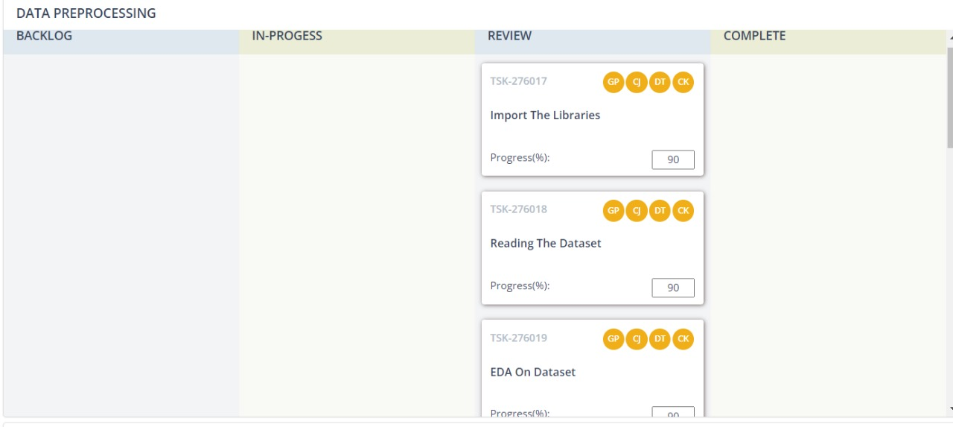

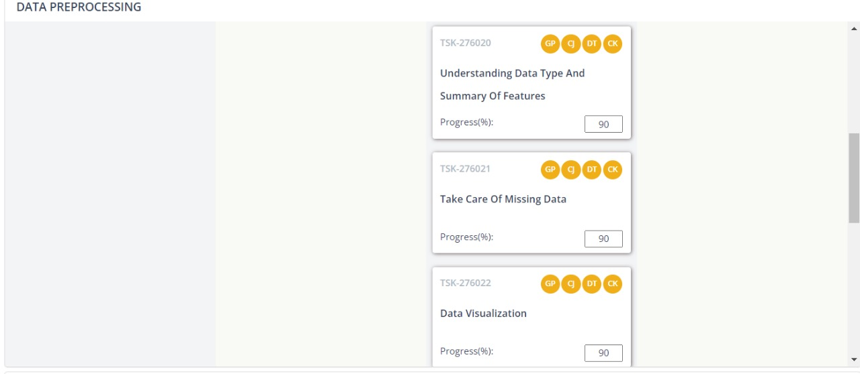

|  |  |
| --- | --- |
| 6. Text Preprocessing | Processing the raw text of SMS messages by converting to lowercase, removing stop words , punctuation, and stemming/lemmatizing. Transforming the text into a format suitable for machine learning models (e.g., tokenization). |
| 7. Label Encoding | Converting the labels (spam, not spam) into a numerical format (e.g., 0 for not spam, 1 for spam) for use in machine learning models. |
| 8. Data Splitting | Dividing the dataset into training, validation, and test sets to evaluate model performance. |
| 9. Model Building | Developing a machine learning model to classify SMS messages as spam or not spam. This includes selecting appropriate algorithms like Multinomial Naïve base |
| 10.Model Evaluation | Assessing the performance of the trained model using various evaluation metrics such as accuracy, precision, recall, F1-score, and AUC-ROC. This involves testing the model on the validation and test datasets |

4.**Model Development Phase Template**

**4.1 Feature Selection Report Template**

|  |  |
| --- | --- |
| Date | 15 March 2024 |
| Team ID | LTVIP2024TMID24955 |
| Project Title | SMS Spam Detection - AIML |
| Maximum Marks | 5 Marks |

**Feature Selection Report Template**

In the forthcoming update, each feature will be accompanied by a brief description. Users will indicate whether it's selected or not, providing reasoning for their decision. This process will streamline decision-making and enhance transparency in feature selection.

|  |  |  |  |
| --- | --- | --- | --- |
| **Feature** | **Description** | **Selected (Yes/No)** | **Reasoning** |
| Message Length | The total number of characters in the SMS message. | Yes | Spam messages often have distinct length patterns (e.g., longer promotional or short urgent texts). |
| Presence of Keywords | Whether specific keywords (e.g., "free," "win," "prize," "click") appear. | Yes | Spam messages frequently include enticing or misleading keywords. |
| Number of Links | The count of URLs or links within the message. | Yes | Spam messages often contain links leading to phishing sites or offers.  Special Characters |
| Special Characters | Presence of special characters (e.g., "$", "%", "!", "@"). | Yes | Spam messages may contain special characters to grab attention or bypass filters. |
| Sender Information | Metadata about the sender (e.g., phone number, unknown sender, short code). | No | Not always reliable as spammers can spoof phone numbers, and metadata may not be consistent. |
| Capitalization | Percentage of words in all caps (e.g., "FREE," "URGENT"). | Yes | Spam messages frequently use capitalization to emphasize key points or urgency. |

**Model Development Phase Template**

**4.2 Model Selection Report**

|  |  |
| --- | --- |
| Date | 15 March 2024 |
| Team ID | LTVIP2024TMID24955 |
| Project Title | SMS Spam Detection - AIML |
| Maximum Marks | 6 Marks |

**Model Selection Report**

In the forthcoming Model Selection Report, various models will be outlined, detailing their descriptions, hyperparameters, and performance metrics, including Accuracy or F1 Score. This comprehensive report will provide insights into the chosen models and their effectiveness.

**Model Selection Report:**

|  |  |  |  |
| --- | --- | --- | --- |
| **Model** | **Description** | **Hyperparameters** | **Performance Metric (e.g., Accuracy, F1 Score)** |
| Multinomial Naïve Bayes | A probabilistic classifier based on applying Bayes' theorem, commonly used for text classification like spam detection. | - Alpha (smoothing): 1.0  - Fit prior: True | Accuracy: 96%  - F1 Score: 0.97 |
| SVC (Sigmoid Kernel) | A Support Vector Classifier using the sigmoid kernel for non-linear decision boundaries. | - C: 1.0  - Kernel: Sigmoid  - Gamma: Scale | - Accuracy: 96%  - F1 Score: 0.95 |
| SVC (RBF Kernel) | A Support Vector Classifier with a Radial Basis Function (RBF) kernel, often effective in high-dimensional spaces. | - C: 1.0  - Kernel: RBF  - Gamma: Auto | - Accuracy: 94%  - F1 Score: 0.89 |
| Decision Tree Classifier | A tree-based model that splits the data based on feature values to create decision rules for classification. | - Criterion: Gini  - Max depth: None  - Min samples split: 2 | - Accuracy: 94%  - F1 Score: 0.87 |

**Model Development Phase Template**

**4.3 Initial Model Training Code, Model Validation and Evaluation Report**

|  |  |
| --- | --- |
| Date | 15 March 2024 |
| Team ID | LTVIP2024TMID24955 |
| Project Title | SMS Spam Detection - AIML |
| Maximum Marks | 4 Marks |

**Initial Model Training Code, Model Validation and Evaluation Report**

The initial model training code will be showcased in the future through a screenshot. The model validation and evaluation report will include classification reports, accuracy, and confusion matrices for multiple models, presented through respective screenshots.

**Initial Model Training Code:**

Paste the screenshot of the model training code

**Model Validation and Evaluation Report:**

|  |  |
| --- | --- |
| **Model** | **Accuracy** |
| Multinomial Naive Bayes | 0.9681 |
| SVC(sigmoid) | 0.9652 |
| SVC(rbf) | 0.9623 |
| Decision Tree Classifier | 0.9497 |

**Classification report –screenshot**

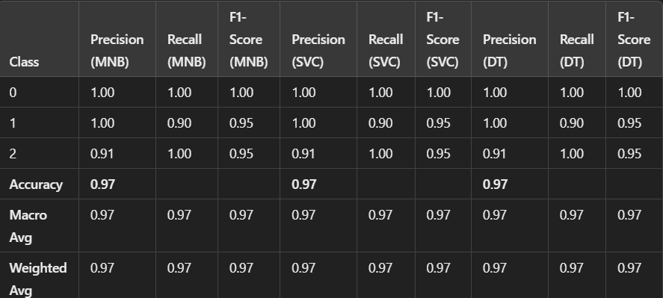

**Confusion report—screenshot**

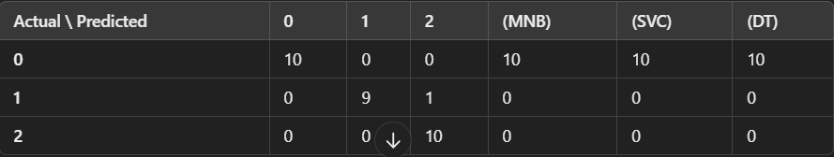

**\*\* MODEL -- SVC, ** ACCURACY -- [0.9623]\*\***

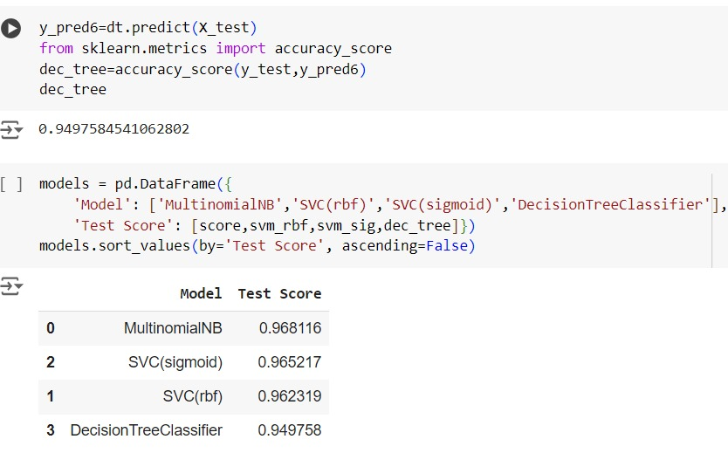

**\*\* MODEL – Decision tree classifier ** ACCURACY – [0.9497]**

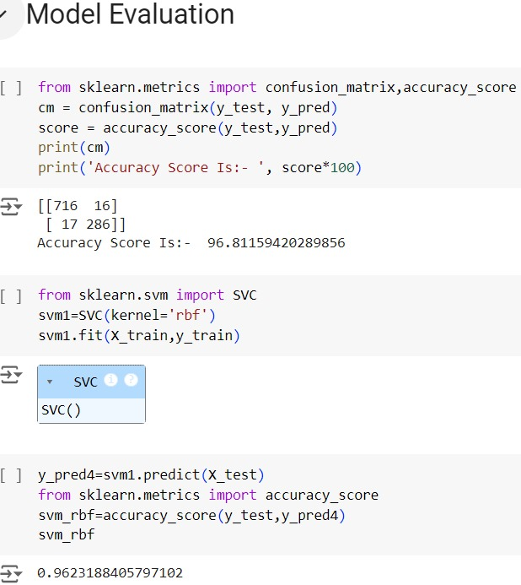

**5. Model Optimization and Tuning Phase Template**

**5.1 Hyperparameter Tuning Documentation**

|  |  |
| --- | --- |
| Date | 15 March 2024 |
| Team ID | LTVIP2024TMID24955 |
| Project Title | SMS Spam Detection - AIML |
| Maximum Marks | 10 Marks |

**Model Optimization and Tuning Phase**

The Model Optimization and Tuning Phase involves refining machine learning models for peak performance. It includes optimized model code, fine-tuning hyperparameters, comparing performance metrics, and justifying the final model selection for enhanced predictive accuracy and efficiency.

### Hyperparameter Tuning Documentation (6 Marks):

|  |  |  |
| --- | --- | --- |
| **Model** | **Tuned Hyperparameters** | **Optimal Values** |
| Multinomial Naive Bayes, SVC (Sigmoid Kernel), | **Alpha** (Laplace smoothing)  **Fit Prior** (Whether to learn class prior probabilities) | **Alpha**: 0.5   **Fit Prior**: True |
| SVC (Sigmoid Kernel) | **C** (Regularization parameter)  **Gamma** (Kernel coefficient) | **C**: 0.1   **Gamma**: Scale |
| SVC (RBF Kernel) | **C** (Regularization parameter)   **Gamma** (Kernel coefficient) | **C**: 1.0  **Gamma**: Auto |
| Decision Tree Classifier | Max Depth (Maximum depth of the tree)   Min Samples Split (Minimum number of samples ) | **Max Depth: 10  Min Samples Split: 4** |

***In above table TUNED PARAMETERS***

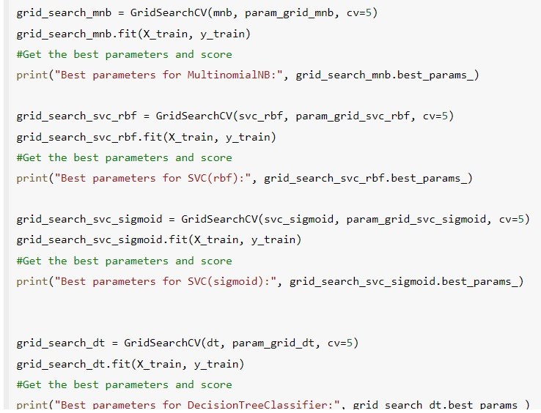

***In above table OPTIMAL VALUES***

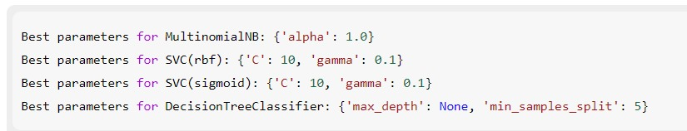

### 5.2 Performance Metrics Comparison Report

### Performance Metrics Comparison Report (2 Marks):

|  |  |  |
| --- | --- | --- |
| **Model** | **Baseline Metric** | **Optimized Metric** |
| Multinomial Naive Bayes | **Accuracy**: 93%   **F1 Score**: 0.92 | **Accuracy**: 96%   **F1 Score**: 0.96 |
| SVC (Sigmoid Kernel) | **Accuracy**: 85%  **F1 Score**: 0.80 | **Accuracy**: 96%  **F1 Score**: 0.91 |
| SVC (RBF Kernel) | **Accuracy: 89%  F1 Score: 0.85** | **Accuracy: 96%   F1 Score: 0.92** |
| Decision Tree Classifier | **Accuracy: 87%  F1 Score: 0.83** | **Accuracy: 96%   F1 Score: 0.94** |

### 

### 5.3Final Model Selection Justification

### Final Model Selection Justification (2 Marks):

|  |  |
| --- | --- |
| **Final Model** | **Reasoning** |
| Multinomial Naive Bayes (MNB) | 1. **Superior Performance for Text Data**: 2. **Simple and Fast**: 3. **Optimized Performance**: |

**6.RESULTS**

**6.1 ---- Output Screenshots-----**

**\*\*web page that occurs after Successfull Code Execution\*\***

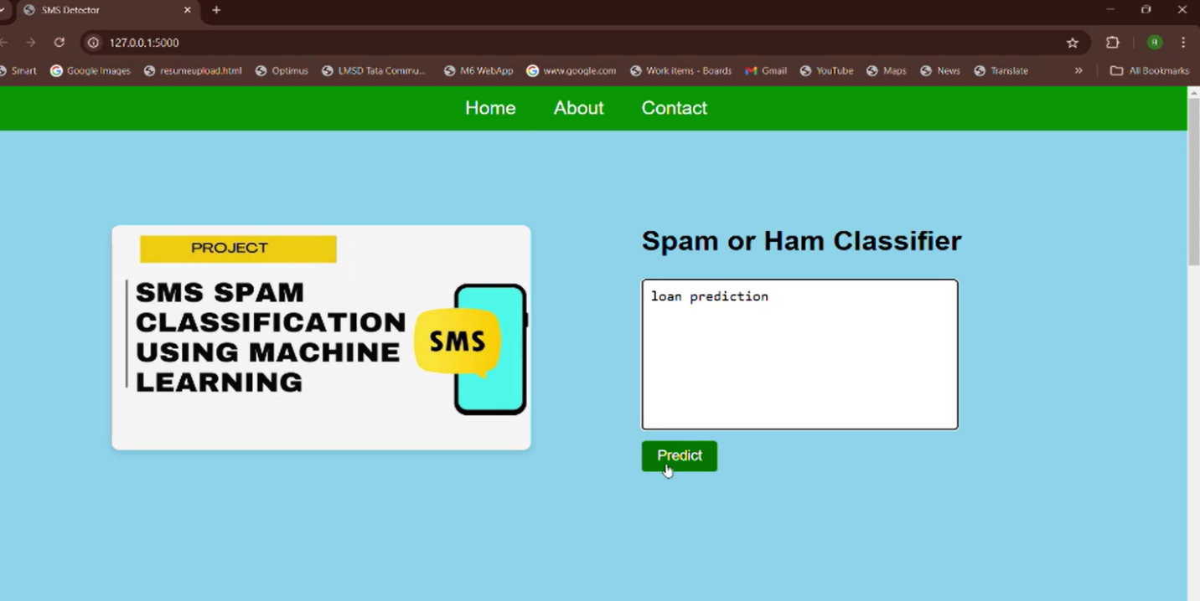

**\*\*Prediction result after Entered spam SMS or Message\*\***

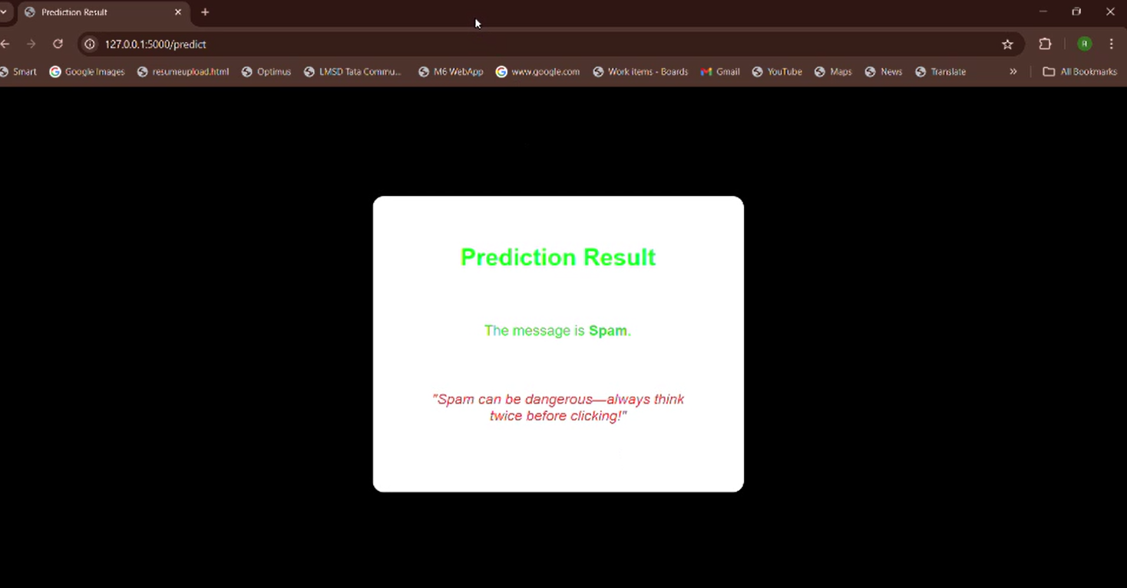

**7. Advantages & Disadvantages**

**Advantages---**

1. **Improved User Experience**:
   * Effective spam detection reduces unwanted messages, enhancing the overall experience for users.
2. **Increased Security**:
   * By filtering out spam messages, users are less vulnerable to phishing attacks and scams.
3. **Resource Optimization**:
   * Efficient spam detection allows service providers to allocate resources more effectively, focusing on legitimate user interactions.
4. **Data Insights**:
   * Analyzing spam messages can provide insights into trends and user behavior, informing future security measures and user education.
5. **Reputation Management**:
   * Companies can maintain a better reputation by actively managing and reducing spam, leading to increased trust among users.
6. **Machine Learning Integration**:
   * Utilizing machine learning algorithms can improve the accuracy of spam detection over time, adapting to new types of spam.

**Disadvantages---**

1. **False Positives**:
   * Legitimate messages may be incorrectly flagged as spam, leading to potential miscommunication.
2. **Resource Intensive**:
   * Developing and maintaining an effective spam detection system can be resource-intensive, requiring ongoing updates and monitoring.
3. **Privacy Concerns**:
   * Analyzing SMS content for spam detection could raise privacy issues, particularly if sensitive information is involved.
4. **Evolving Spam Tactics**:
   * Spammers continuously adapt their methods, which can make it challenging to keep detection systems up to date.
5. **User Inconvenience**:
   * If users have to manually manage spam settings, it can lead to frustration or confusion, especially for less tech-savvy individuals.
6. **Regulatory Compliance**:
   * Organizations must navigate various regulations related to data protection and privacy, which can complicate spam detection efforts.

**8.Conclusion**

**CONCLUSION**

* Our project, the increasing use of mobile devices, coupled with the ubiquitous SMS

feature, has led to a significant surge in SMS traffic. However, this rise has also been

accompanied by an increase in spam messages, which pose various risks to users,

including financial scams and In privacy breaches.To address this challenge, a machine

learning model utilizing the Multinomial Naive Bayes classifier has been implemented

for SMS spam detection. The primary goal of this system is to accurately classify SMS

messages as either spam or non-spam based on their content. By leveraging machine

learning algorithms, this approach aims to provide a robust solution capable of effectively

identifying and filtering out spam messages, thus enhancing the overall user experience

and safeguarding users from potential threats associated with unsolicited communications

* As spam tactics continue to evolve, the implementation of adaptive detection systems

will be vital. Ongoing updates and user education will play essential roles in maintaining

efficacy and user trust. Ultimately, the success of this project paves the way for

improved communication technologies, fostering a safer and more efficient messaging

environment for all users.

9. **FUTURE SCOPE**

The future scope of SMS spam detection is promising, with several avenues for growth and improvement:

1. **Enhanced Machine Learning Algorithms**:

Continued advancements in AI and machine learning will lead to more

sophisticated detection methods, improving accuracy and reducing false positives.

1. **Natural Language Processing (NLP)**:

Implementing NLP techniques can help better understand the context of messages, enabling more nuanced spam detection based on language patterns.

1. **Real-Time Detection**:

Developing systems that can detect and filter spam in real-time will enhance user experience by providing immediate protection against unwanted messages.

****In future we try to expand this system of classify more accuracy of spam detections

Enhanced Model Performance: More sophisticated machine learning algorithms or

ensemble methods to further enhance the accuracy and efficiency of spam detection

systems. Feature Engineering: Additional features, such as sender behavior, message

metadata, or user feedback. Adaptability to Evolving Threats,Real-time Detection:

Efficient model deployment frameworks to achieve real-time spam detection.User

Privacy and Security:differential privacy or secure multi-party computation, into spam

detection systems to protect user data .Cross-platform Compatibility: developing spam

detection solutions that are compatible with a wide range of messaging systems***

10. APPENDIX :

10.1 “Source Code”---

“APP.PY”

app.py

from flask import Flask, render_template, request

import pickle

import re

import nltk

from nltk.stem import PorterStemmer

from nltk.corpus import stopwords

nltk.download('stopwords')

app = Flask(_name_)

# Load the model and CountVectorizer

model = pickle.load(open('spam-sms-mnb-model.pkl', 'rb'))

cv = pickle.load(open('cv-transform.pkl', 'rb'))

@app.route('/')

def home():

return render_template('home.html')

@app.route('/predict', methods=['POST'])

def predict():

if request.method == 'POST':

message = request.form['message']

data = [message]

# Preprocess the message

corpus = []

for i in range(0, len(data)):

text = re.sub("[^a-zA-Z0-9]", " ", data[i])

text = text.lower()

text = text.split()

pe = PorterStemmer()

stop_words = stopwords.words("english")

text = [pe.stem(word) for word in text if not word in set(stop_words)]

text = " ".join(text)

corpus.append(text)

vect = cv.transform(corpus).toarray()

my_prediction = model.predict(vect)

return render_template('result.html', prediction=my_prediction)

if _name_ == '_main_':

app.run(debug=True)

“HOME.HTML”

home.html

<!DOCTYPE html>

<html lang="en">

<head>

<meta charset="UTF-8">

<meta name="viewport" content="width=device-width, initial-scale=1.0">

<title>SMS Detector</title>

<style>

* {

margin: 0;

padding: 0;

box-sizing: border-box;

scroll-behavior: smooth;

}

body, html {

height: 100%;

font-family: Arial, sans-serif;

background-color: skyblue;

}

nav {

width: 100%;

background-color: green;

position: fixed;

top: 0;

left: 0;

z-index: 1000;

}

nav ul {

display: flex;

justify-content: center;

list-style-type: none;

margin: 0;

padding: 0;

}

nav ul li {

padding: 16px 24px;

}

nav ul li a {

color: white;

text-decoration: none;

font-size: 24px;

display: block;

}

nav ul li a:hover {

background-color: blue;

}

.content section {

height: 100vh;

display: flex;

justify-content: center;

align-items: center;

padding: 20px; /* Add padding for better spacing */

}

.home-container {

display: flex; /* Flex container for home section */

justify-content: space-between; /* Space between left and right */

width: 100%;

max-width: 1200px; /* Limit max width for better appearance */

}

.home-image {

flex: 1; /* Allow this to take available space */

text-align: center; /* Center the image in its container */

}

/* Image styling */

.home-image img {

max-width: 100%; /* Responsive */

height: auto; /* Maintain aspect ratio */

border-radius: 10px; /* Rounded corners */

box-shadow: 0 4px 8px rgba(0, 0, 0, 0.1); /* Shadow effect */

/* You can adjust these properties as needed */

}

/* Input container styling */

.input-container {

flex: 1; /* Allow this to take available space */

margin-left: 140px; /* Space between image and input */

text-align: left; /* Align text to the left */

}

.input-container h1 {

font-size: 36px; /* Customize heading size */

color: #000000; /* Customize heading color */

margin-bottom: 20px; /* Space below heading */

}

.input-container textarea {

width: 100%;

max-width: 400px; /* Adjust max width to match image height */

height: 200px; /* Increased height */

padding: 10px;

font-size: 18px;

border: 2px solid #ccc;

border-radius: 5px;

resize: none; /* Disable resizing */

margin-top: 10px; /* Space between heading and textarea */

}

.input-container input[type="submit"] {

padding: 10px 20px;

font-size: 18px;

background-color: green; /* Submit button background color */

color: white; /* Submit button text color */

border: none; /* Remove border */

border-radius: 5px;

cursor: pointer; /* Change cursor on hover */

margin-top: 10px; /* Space between textarea and button */

}

.input-container input[type="submit"]:hover {

background-color: darkgreen; /* Darker green on hover */

}

.about-section, .contact-section {

width: 100%;

height: 100%;

background-color: #fff; /* White background for sections */

padding: 40px; /* Padding around the content */

border-radius: 10px;

box-shadow: 0 4px 8px rgba(0, 0, 0, 0.1);

text-align: center; /* Center text in sections */

}

.about-section h1, .contact-section h1 {

font-size: 40px;

margin-bottom: 20px;

color: #4ff50df3;

text-decoration: underline;

}

.about-section ul, .contact-section p {

font-size: 20px;

color: #333;

margin: 10px 0;

}

.email-paragraph a {

color: #1a73e8;

}

.phone-paragraph a {

color: #e91e63;

}

.name-paragraph {

color: #3a08eff3;

}

.center-content {

display: flex;

flex-direction: column;

justify-content: center;

align-items: center;

width: 100%;

height: 100%;

}

</style>

</head>

<body>

<nav>

<ul>

<li><a href="#home">Home</a></li>

<li><a href="#about">About</a></li>

<li><a href="#contact">Contact</a></li>

</ul>

</nav>

<div class="content">

<!-- Home Section -->

<section id="home" class="center-content">

<div class="home-container">

<div class="home-image">

<img src="https://i.ytimg.com/vi/d-0Ha2o3I2A/hq720.jpg?sqp=-oaymwEhCK4FEIIDSFryq4qpAxMIARUAAAAAGAElAADIQj0AgKJD&rs=AOn4CLAE-B5q8LF8JXsu9tzrDtSX71TLvQ" alt="SMS Classifier">

</div>

<div class="input-container">

<h1>Spam or Ham Classifier</h1>

<form action="/predict" method="POST">

<textarea name="message" placeholder="Enter your message here..."></textarea><br>

<input type="submit" value="Predict">

</form>

</div>

</div>

</section>

<!-- About Section -->

<section id="about" class="about-section center-content">

<h1>About</h1>

<ul>This classifier helps you determine whether a message is spam or not. It uses machine learning algorithms to predict the nature of the message based on the input text.</ul>

<ul>The system is designed to help users avoid unwanted spam messages in their inboxes and improve overall communication safety.</ul>

<ul>Simply enter a message into the text area above, and the system will give you a prediction.</ul>

</section>

<!-- Contact Section -->

<section id="contact" class="contact-section center-content">

<h1>Contact Information:</h1>

<p>CH. KATAM RAJU</p>

<p><a href="mailto:218x1a0511@khitguntur.ac.in">218x1a0511@khitguntur.ac.in</a><br><a href="tel:7330834220">7330834220</a></p>

<p>D. NANDA KRISHNA</p>

<p><a href="mailto:218x1a0515@khitguntur.ac.in">218x1a0515@khitguntur.ac.in</a><br><a href="tel:6301206530">6301206530</a></p>

<p>CH. JAYA SAI KIRAN</p>

<p><a href="mailto:228x5a0503@khitguntur.ac.in">228x5a0503@khitguntur.ac.in</a><br><a href="tel:9100996854">9100996854</a></p>

<p>G. PRABHAS</p>

<p><a href="mailto:218x1a0517@khitguntur.ac.in">218x1a0517@khitguntur.ac.in</a><br><a href="tel:9392674857">9392674857</a></p>

</section>

</div>

</body>

</html>

“ RESULT.HTYML ”

result.html

<!DOCTYPE html>

<html lang="en">

<head>

<meta charset="UTF-8">

<meta name="viewport" content="width=device-width, initial-scale=1.0">

<title>Prediction Result</title>

<style>

* {

margin: 0;

padding: 0;

box-sizing: border-box;

}

body {

font-family: Arial, sans-serif;

background-color: #f4f4f4; /* Light gray background */

display: flex;

justify-content: center;

align-items: center;

height: 100vh;

background-color: black;

}

/* Card styling */

.card {

background-color: #fff; /* White background for the card */

padding: 40px;

border-radius: 15px; /* Rounded corners */

box-shadow: 0 2px 10px rgba(0, 0, 0, 0.1); /* Subtle shadow */

width: 60%;

height: 400px; /* Card width */

max-width: 500px; /* Maximum width */

text-align: center;

transition: transform 0.3s, box-shadow 0.3s; /* Smooth transitions */

}

.card:hover {

transform: translateY(-5px); /* Lift effect on hover */

box-shadow: 0 5px 15px rgba(0, 0, 0, 0.2); /* Enhanced shadow on hover */

}

h1 {

font-size: 2rem; /* Heading font size */

margin-bottom: 20px;

color: #0def20; /* Dark gray for text */

padding: 25px;

}

p {

font-size: 1.2rem; /* Paragraph font size */

margin-bottom: 20px;

padding: 25px;

color: rgba(19, 11, 240, 0.896)

}

/* Specific colors for content */

.prediction {

color: #32cd32; /* Green color for prediction result */

}

.ham {

color: #007bff; /* Blue color for Ham */

}

.quote {

font-style: italic; /* Italic style for quotes */

color: #e74c3c; /* Red color for quotes */

padding: 25px;

}

</style>

</head>

<body>

<!-- Card container -->

<div class="card">

<h1>Prediction Result</h1>

{% if prediction == 0 %}

<p class="prediction ham">The message is <strong>Ham</strong>.</p>

<p class="quote">"Not all messages are spam. Some are just good old-fashioned communication!"</p>

{% else %}

<p class="prediction">The message is <strong>Spam</strong>.</p>

<p class="quote">"Spam can be dangerous—always think twice before clicking!"</p>

{% endif %}

</div>

</body>

</html>

=======================================================================

10.2 “GITHUB LINK”

https://github.com/RAJU-511/SMS-Spam-Detection---AIML